- Program ID : VH001MA1

- Display Layout
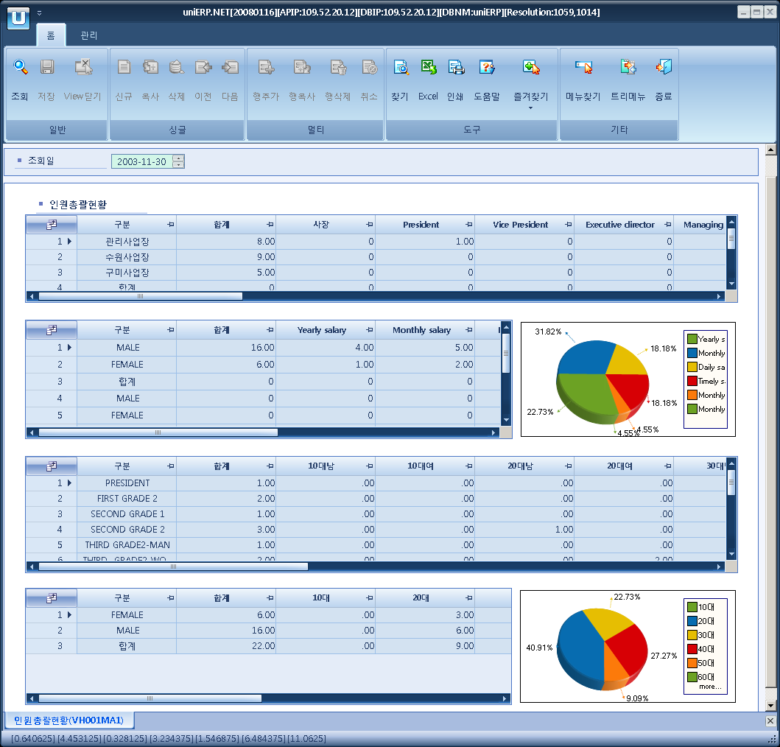

- Event flow
- Click Query button
- OnFncQuery -> DbQuery -> DataChange
- Display Unit combo change
- uniCombo1_ValueChanged -> DataChange

- SQL Statements
- BizArea vs Class
SELECT d.biz_area_nm, e.minor_nm, COUNT(*)
FROM haa010t a, b_cost_center b, b_acct_dept c, b_biz_area d, b_minor e
WHERE a.dept_cd = c.dept_cd
AND c.cost_cd = b.cost_cd
AND c.org_change_id = (SELECT DISTINCT x.org_change_id
FROM b_acct_dept x
WHERE x.org_change_dt = (SELECT MAX(z.org_change_dt)
FROM b_acct_dept z
WHERE z.org_change_dt <= @strDate))
AND d.biz_area_cd = b.biz_area_cd
AND e.major_cd = 'H0002'
AND e.minor_cd = a.roll_pstn
AND a.entr_dt < DATEADD(MONTH, 1, @strDate)
AND (a.retire_dt IS NULL OR a.retire_dt >= @strDate)
GROUP BY d.biz_area_nm, e.minor_nm

- Sex vs Employment type
SELECT b1.minor_nm, b2.minor_nm, COUNT(*)
FROM haa010t a, hdf020t b, b_minor as b1, b_minor as b2
WHERE b.emp_no = a.emp_no
AND a.entr_dt < DATEADD(MONTH, 1, @strDate)
AND b1.major_cd = 'H0115'
AND b1.minor_cd = a.sex_cd
AND b2.major_cd = 'H0005'
AND b2.minor_cd = b.pay_cd
AND (a.retire_dt IS NULL OR a.retire_dt >= @strDate)
GROUP BY b1.minor_nm, b2.minor_nm

- Sex vs Class vs Age
SELECT a.pay_grd1, c.minor_nm,
SUM(1),
SUM(CASE WHEN DATEDIFF(YEAR, b.birt, @strDate)+1 BETWEEN 10 AND 19 AND b.sex_cd='1' THEN 1 ELSE 0 END) '10M',
SUM(CASE WHEN DATEDIFF(YEAR, b.birt, @strDate)+1 BETWEEN 10 AND 19 AND b.sex_cd='2' THEN 1 ELSE 0 END) '10F',
SUM(CASE WHEN DATEDIFF(YEAR, b.birt, @strDate)+1 BETWEEN 20 AND 29 AND b.sex_cd='1' THEN 1 ELSE 0 END) '20M',
SUM(CASE WHEN DATEDIFF(YEAR, b.birt, @strDate)+1 BETWEEN 20 AND 29 AND b.sex_cd='2' THEN 1 ELSE 0 END) '20F',
SUM(CASE WHEN DATEDIFF(YEAR, b.birt, @strDate)+1 BETWEEN 30 AND 39 AND b.sex_cd='1' THEN 1 ELSE 0 END) '30M',
SUM(CASE WHEN DATEDIFF(YEAR, b.birt, @strDate)+1 BETWEEN 30 AND 39 AND b.sex_cd='2' THEN 1 ELSE 0 END) '30F',
SUM(CASE WHEN DATEDIFF(YEAR, b.birt, @strDate)+1 BETWEEN 40 AND 49 AND b.sex_cd='1' THEN 1 ELSE 0 END) '40M',
SUM(CASE WHEN DATEDIFF(YEAR, b.birt, @strDate)+1 BETWEEN 40 AND 49 AND b.sex_cd='2' THEN 1 ELSE 0 END) '40F',
SUM(CASE WHEN DATEDIFF(YEAR, b.birt, @strDate)+1 BETWEEN 50 AND 59 AND b.sex_cd='1' THEN 1 ELSE 0 END) '50M',
SUM(CASE WHEN DATEDIFF(YEAR, b.birt, @strDate)+1 BETWEEN 50 AND 59 AND b.sex_cd='2' THEN 1 ELSE 0 END) '50F',
SUM(CASE WHEN DATEDIFF(YEAR, b.birt, @strDate) BETWEEN 60 AND 69 AND b.sex_cd = '1' THEN 1 END) AS '60M',
SUM(CASE WHEN DATEDIFF(YEAR, b.birt, @strDate) BETWEEN 60 AND 69 AND b.sex_cd = '2' THEN 1 END) AS '60F',
SUM(CASE WHEN DATEDIFF(YEAR, b.birt, @strDate) > 69 AND b.sex_cd = '1' THEN 1 ELSE 0 END) AS '70M',
SUM(CASE WHEN DATEDIFF(YEAR, b.birt, @strDate) > 69 AND b.sex_cd = '2' THEN 1 ELSE 0 END) AS '70F'
FROM hdf020t a, haa010t b, b_minor c
WHERE a.emp_no = b.emp_no
AND b.entr_dt < DATEADD(MONTH, 1, @strDate)
AND c.major_cd = 'H0001'
AND c.minor_cd = a.pay_grd1
AND (b.retire_dt IS NULL OR b.retire_dt >= @strDate)
GROUP BY a.pay_grd1, c.minor_nm

- Sex vs Age
SELECT b1.minor_nm,
SUM(1) AS '00',
SUM(CASE WHEN DATEDIFF(YEAR, a.birt, @strDate) + 1 BETWEEN 10 AND 19 THEN 1 ELSE 0 END) AS '10',
SUM(CASE WHEN DATEDIFF(YEAR, a.birt, @strDate) + 1 BETWEEN 20 AND 29 THEN 1 ELSE 0 END) AS '20',
SUM(CASE WHEN DATEDIFF(YEAR, a.birt, @strDate) + 1 BETWEEN 30 AND 39 THEN 1 ELSE 0 END) AS '30',
SUM(CASE WHEN DATEDIFF(YEAR, a.birt, @strDate) + 1 BETWEEN 40 AND 49 THEN 1 ELSE 0 END) AS '40',
SUM(CASE WHEN DATEDIFF(YEAR, a.birt, @strDate) + 1 BETWEEN 50 AND 59 THEN 1 ELSE 0 END) AS '50',
SUM(CASE WHEN DATEDIFF(YEAR, a.birt, @strDate) BETWEEN 60 AND 69 THEN 1 ELSE 0 END) AS '60',
SUM(CASE WHEN DATEDIFF(YEAR, a.birt, @strDate) > 69 THEN 1 ELSE 0 END) AS '70이상'
FROM haa010t a, b_minor AS b1
WHERE a.entr_dt < DATEADD(MONTH, 1, @strDate)
AND b1.major_cd = 'H0115'
AND b1.minor_cd = a.sex_cd
AND (a.retire_dt IS NULL OR a.retire_dt >= @strDate)
GROUP BY b1.minor_nm

